PENGAJUAN DANA 27 SEPTEMBER 2024

1. CABUT BERKAS JEEP B 1454 EUY

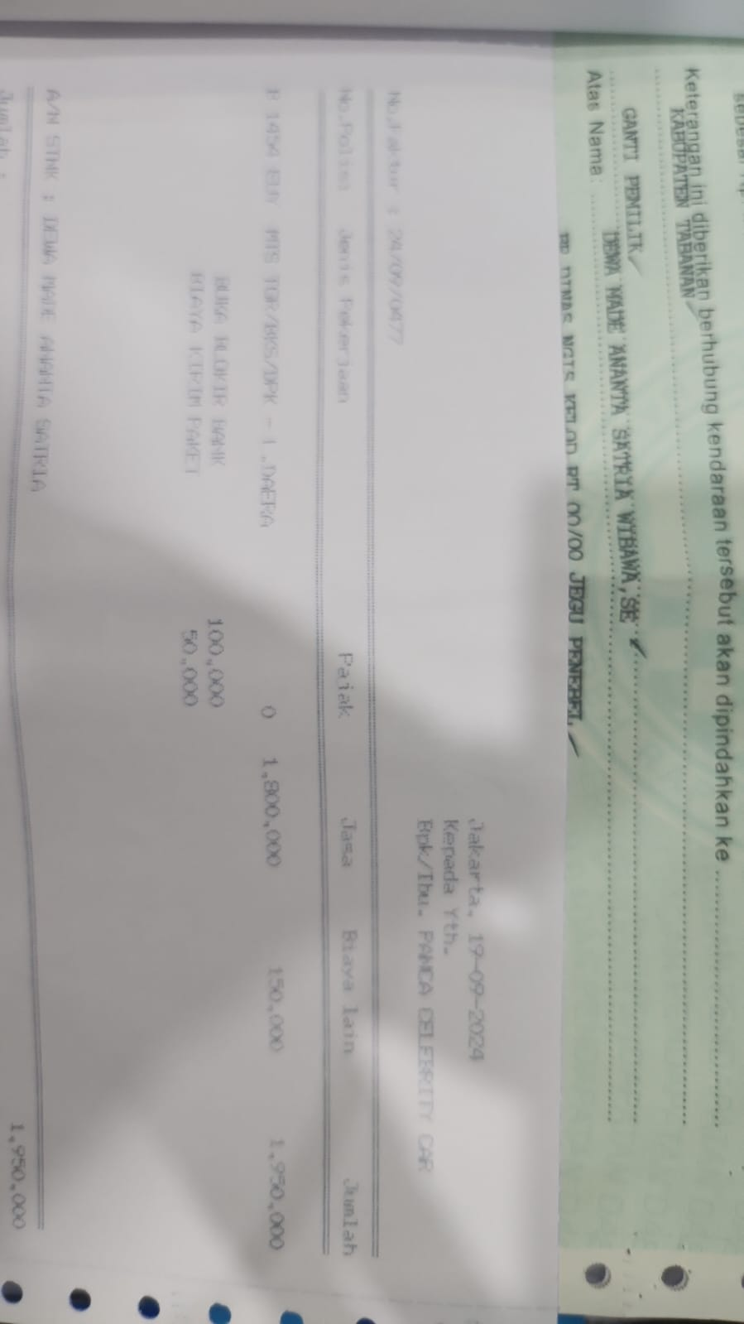

1. SERVICE PLAFON MACAN M 828

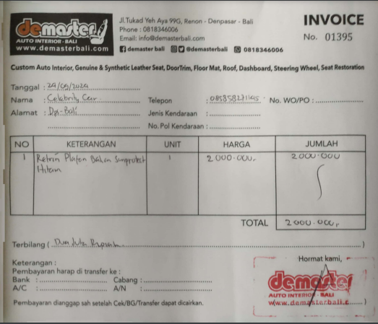

1. SERVICE MACAN ABS M 828

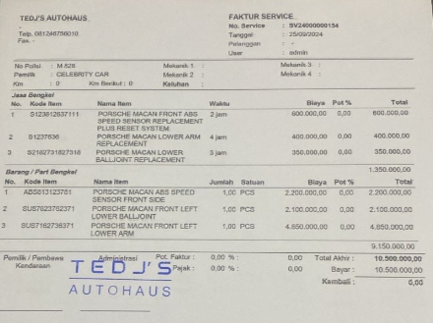

1. SERVICE MACAN 2014 L 1434 EN

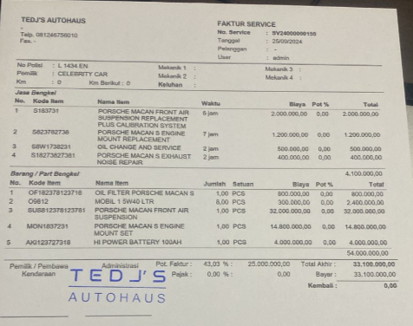

1. BBN SUZUKI X-OVER

